
Food and Grocery Code Supervisor
  - Annual Report 2024–25

© Commonwealth of Australia 2026
ISBN: 978-1-923278-52-3
This publication is available for your use under a Creative Commons Attribution 4.0 International licence, with the exception of the Commonwealth Coat of Arms, the Treasury logo, photographs, images, third party materials, materials protected by a trademark, signatures and where otherwise stated. The full licence terms are available from creativecommons.org/licenses/by/4.0/legalcode.
Use of Treasury material under a Creative Commons Attribution 4.0 International licence requires you to attribute the work (but not in any way that suggests that Treasury endorses you or your use of the work).
Treasury material used ‘as supplied’
Provided you have not modified or transformed Treasury material in any way including, for example, by changing the Treasury text; calculating percentage changes; graphing or charting data; or deriving new statistics from published Treasury statistics – then Treasury prefers the following attribution:
Source: The Australian Government, the Treasury
Derivative material
If you have modified or transformed Treasury material, or derived new material from those of the Treasury in any way, then Treasury prefers the following attribution:
Based on material from the Australian Government Department of the Treasury, Food and Grocery Code Supervisor Annual Report 2024–25
Use of the Coat of Arms
The terms under which the Coat of Arms can be used are set out on the Department of the Prime Minister and Cabinet website (see www.pmc.gov.au/government/commonwealth-coat-arms).
Other uses
Enquiries regarding this licence and any other use of this document are welcome at:
Manager
Media Unit
The Treasury
Langton Crescent
Parkes ACT 2600
Email: media@treasury.gov.au
In the spirit of reconciliation, the Treasury acknowledges the Traditional Custodians of country throughout Australia and their connections to land, sea and community. We pay our respect to their Elders past and present and extend that respect to all Aboriginal and Torres Strait Islander peoples.

Contents
Foreword 1
Executive summary 3
Survey results 3
Emerging themes 4
Overview of the Code 6
Composition of the supermarket sector 6
Code Supervisor’s activities 7
Engagement with the sector 7
Formal complaints received 8
Code Supervisor’s observations on supplier awareness of the Code 8
Code Mediator reports 9
Survey of suppliers 10
Process for conducting the survey 10
General observations 11
Improved outcomes 11
Emerging focus areas 12
Range reviews 12
Retail margins and price negotiations 13
Transparency in pricing metrics 13
Promotions and investment 14
Retribution 16
Communications and notice periods 19
Fresh produce suppliers 19
Impacts on small businesses 20
Contracting out exemptions 21
Conclusion 22
Survey methodology 22
Identification of key findings 22
Overall score ranking methodology 22
Survey of large grocery businesses 23
Training and compliance 23
Supplier relationships 23
Communicating of dispute resolution avenues 23
Price increase notifications and negotiations 23
Range reviews and delisting 24
Retribution 24
Marketing support 24
Fresh produce 24
Effectiveness of the Code 25

Foreword
This is the first report by the Food and Grocery Code Supervisor, Professor Elizabeth Sarofim, under the new mandatory Food and Grocery Code which came into effect on 1 April 2025. It reports on the first annual survey of suppliers’ experiences and emerging issues under the new Code.
By way of important background to this year’s survey design and methodology, most manufacturers and growers go through one or more of the large grocery businesses to get their products to Australian consumers. Approximately 85% of food and grocery supply occurs through the four large grocery businesses covered by the new Code being Woolworths, Coles, Aldi and Metcash. The two largest of these, Woolworths and Coles, hold a critical role in this supply with 68% of all food and grocery supply to consumers going through them. The precise breakdown of supply in the sector is set out in greater detail in this report.
The introduction of the new mandatory Code marks an important commitment to expressly acknowledging and addressing this imbalance in bargaining power between large grocery businesses and the manufacturers and growers that supply them. Despite popular misconception, this imbalance does not arise simply by virtue of size differences between a large grocery business and a supplier, but from the fact that the supermarkets, particularly Woolworths and Coles, are dominant intermediaries with control over how products flow from suppliers to consumers. The Code expressly acknowledges this asymmetry and requires the supermarkets to treat suppliers with honesty, fairness, good faith and without retribution.
A hypothetical large grocery business in this environment will have a genuine commercial incentive to pursue playbooks intended to:
- extract supplier promotional spend to offer cheaper products to consumers without sacrificing its own margin
- impose consequences relating to shelf placement, ranging, cancellation of promotions and refusal to deal to extract agreement from suppliers to its trading terms even if they have no commercial benefit to suppliers
- disclose range review criteria that are expressed so loosely so that they can be deployed selectively to put pressure on different suppliers
- streamline and reduce product lines and ranging using tenuous links to changes in consumer behaviour and in-store activity where the real purpose is to replace them with goods that deliver a better commercial return for the large grocery business.
The existence of the protections in the Code and the provisions concerning unconscionability, unfair practices and misuse of market power in the Competition and Consumer Act 2010 are intended to operate as critical pillars in managing and controlling the untrammelled pursuit of such practices by a hypothetical large grocery business. This goes to the sovereignty and security of Australia’s food and grocery supply given the concentrated nature of the market. Recent global volatility and import supply chain disruptions underscore the importance of the Code’s objectives in maintaining a competitive, sustainable environment for Australian manufacturers and growers that also employ hundreds of thousands of Australians.
With this background in mind, the Code Supervisor’s first survey of suppliers under the new Code was enhanced to reflect the new Code’s purposes and objectives.
Whilst the questions from prior years’ surveys were retained to allow year-on-year trend comparison through the Code Supervisor’s online dashboard, new targeted questions to support better insights were introduced. These included questions relating to supplier experiences in negotiating prices, participation in promotions, ordering processes and retribution. Additionally, an entirely new section of the survey was introduced targeting fresh produce suppliers to gauge experiences surrounding potentially unfair risk allocation, forecasting and pricing practices faced by growers in this particularly challenging sector.
The additional questions included in this year’s survey included greater reliance on qualitative questions with free text responses so that suppliers can explain their experiences more clearly without the constraints of quantitative question framing and interpretation.
This year’s survey results show improvement in supplier relationships across a range of metrics but reflect a sector still facing persistent challenges. Positive shifts include greater perceptions of fairness, improved conduct relating to payment times and an uptick on the previous year in suppliers reporting they had not experienced any issues in the financial year. However, the results also highlight substantial issues in the sector. Challenges in price negotiation transparency, promotional investment expectations, communication variability, and the impacts on small or fresh produce suppliers remain prominent themes in the supplier responses.
This report commences with an executive summary section which details the overarching scores and rankings arising from the annual survey of suppliers and the emerging themes arising from the Code Supervisor’s engagement with suppliers.
For the first time, the annual report reporting on the survey conducted under the Code will include de-identified extracts from the survey responses. Where this is done in the report, it is on the basis that the extract is representative of recurring themes in the survey data.
Whilst supplier subjective experiences are only one piece of the picture, they provide an important basis for areas of further exploration by the Code Supervisor and other regulatory activities to build both understanding and trust in the Code and its processes.

Executive summary

Survey results
A ranking of the performance of the large grocery businesses has been compiled based on the results of the supplier survey. This information is again being made public to promote greater transparency and to foster greater competition in the sector.
Table 1: Ranking of the performance of the large grocery businesses
Large grocery business | 2024–25 ranking | 2023–24 ranking
Aldi | 1st | 1st
Metcash | 2nd | 2nd
Coles | 3rd | 3rd
Woolworths | 4th | 4th
419 suppliers responded to the survey. Many provided responses for each of the large grocery businesses they supply to, resulting in a total of 947 individual responses.
More information about the process for conducting the survey and general observations from the survey results is in the ‘Survey of suppliers’ section of this report.
Suppliers to Woolworths reported an increase in experiencing ‘no issues’ from 64% to 73%, while Coles and Metcash all saw smaller improvements in suppliers reporting no issues. Aldi’s results remained stable, maintaining the highest score on this metric. There was also a continued improvement across the board in deductions without consent and reductions in late payments.
However, the quantitative and qualitative responses to the new targeted questions put to suppliers in the most recent survey provide important colour and context for the issues relating to the Code’s prohibition against retribution. The four largest grocery businesses each report strong commitment to combating fears around retribution. The Code Supervisor’s observation is that the concept appears to be difficult for suppliers to isolate from the unequal bargaining power which is a consistent and pervasive commercial aspect of their day-to-day dealings and underpinned the introduction of a mandatory code.
Accordingly, this year’s survey went beyond the pre-existing general question on retribution. It specifically asked suppliers to reflect on specific commercial points of interaction with supermarkets where retribution in Australia or other markets may manifest itself.
The responses to these additional questions and the qualitative responses in particular are important in understanding more about the realities of the supplier experience. These experiences do not align squarely with the quantitative results on the general high-level question on retribution in the survey.
As one survey respondent noted:
We are currently being told that we are “below the category average” in terms of margin and told “a range review is coming... what do we plan to do about this?” Average means half of suppliers will be above and half will be below. The premise of expecting every supplier and every product to be “above average” is unfair. As suppliers we are expected to give them more margin when we cannot increase our prices and yet they want us to drop our prices to them to give them an increased profit margin. The “ask” and expectation to do this as a means of whether they continue to range a product puts us as a supplier under unfair duress leading into a range review. We are terrified of the outcome. And the prospect of losing a large % of your business which you know will have negative effects for your staff. This practice should just not be allowed. Over many years they have continued to increase their profits by putting up prices without us putting up our prices.
The slightly improved quantitative retribution score in this year’s survey should therefore be viewed with caution and the Code Supervisor will continue to focus on areas of commercial interface between suppliers and the large grocery businesses where retribution may occur, including:
- requests for incremental promotional or media spend to fund customer offer initiatives and any consequences in terms of ranging, shelf placement and pricing where a supplier does not agree to do so because there is no commercial benefit to the supplier or it would lead the supplier to trade below cost
- consequences on volume, ranging, shelf placement and retail pricing after a supplier asks for a price increase to reflect increases in input costs, even where it is accepted by the supermarket
- range reviews and differences in the way in which certain criteria are deployed differently and with different weighting to different suppliers in the same category
- delisting processes
- any conflation or weaponisation of these otherwise disparate commercial processes for a collateral purpose.

Emerging themes
The Code Supervisor’s engagement with suppliers since 1 April 2025 has highlighted several areas where supermarket performance remains inconsistent or concerning. Several of these emerged in the survey responses and in the interests of efficiency are set out and dealt with in greater detail in the ‘Emerging focus areas’ section of this report.
Additional areas of ongoing concern, and in many instances confusion, relate to the way in which range and space decisions are made. Whilst the Code is, in many areas, relatively high level in its guidance, the principles of fairness and good faith are woven throughout. This necessitates further exploration of how the large grocery businesses make range decisions, allocate shelf space and engage with suppliers in that regard both verbally and in writing.
Suppliers have further expressed concern that the current regulatory focus on consumer-facing shelf pricing compliance like price gouging fails to take account of upstream interactions supermarkets have with suppliers. This includes discussions about range, space, and requests for supplier margin sacrifice in the form of promotional contribution. Almost half of supplier responses describe price negotiations as involved or challenging. Half of supplier responses said retailers ‘always or mostly’ seek incremental retail margin (i.e. more discount) and investment during range reviews.
By far the most prevalent frustration of suppliers reported to the Code Supervisor relates to the lack of understanding of the ways in which seemingly disparate supermarket decision-making processes are in fact connected.
It was noted above in relation to the survey’s more granular engagement with the concept of retribution that suppliers reported how supermarkets conflate range review processes with the ongoing pressure on suppliers to meet challenging margin expectations.
Another example includes where supplier price increase requests are accepted but the supermarket elects to maintain its existing retail price. In time, the supermarket uses its reduced margin as justification to cancel planned promotions and/or flag de-listing due to poor performance against the average category margin.
To an outsider not experienced in the day-to-day commercial realities of this sector, the initial price increase process and the subsequent decision about promotions or delisting may be treated as two separate commercial processes: the supermarket accepted the cost price increase request in the first process and now appears to be acting in its commercial interests to preserve profitability in the second process. To a seasoned operator in this space, the link between the two processes is more apparent: a proposed de-listing in circumstances where the supplier’s product otherwise performs strongly across key objective metrics does not make commercial sense; and a supermarket that cancels planned promotions previously agreed with its supplier necessarily harms itself in foregoing volume of sales and the opportunity to offer a competitive promotional price to the market. Certain inferences can be drawn about why the supermarket nonetheless elects to behave and interact with the relevant supplier in this way.
As one survey respondent noted:
It is made implicitly clear that retailer margin must always increase when there are new products being ranged or if there is a cost price increase otherwise we will be punished and lose space on shelf or ranging of products.
Finally, fresh produce suppliers report that they continue to face unfair allocation of the growing and forecasting risk. Only 13% of fresh produce suppliers reported always being able to negotiate prices fairly for their produce. Suppliers report that the verbal negotiations in the lead-up to a supplier being asked to input a price into a supermarket’s portal system continues to create a difference between prices initially agreed and prices actually paid. While this may be disputed by the large grocery business, this makes price transparency in this space incredibly difficult for fresh produce suppliers to gauge beyond what is being represented to them verbally by the supermarkets. The reliance on the phrase ‘market price’ by Coles and Woolworths in the context of these verbal price negotiations with fresh produce suppliers is problematic as suppliers are often not clear on the basis for the use of that phrase.
These emerging themes will form the basis of the Code Supervisor’s focus for the coming year.

Overview of the Code
The Food and Grocery Code is established under the Competition and Consumer Act 2010. It was first introduced as a voluntary code in 2015. The Code is designed to address an imbalance in bargaining power between large grocery retailers or wholesalers and their suppliers to support a competitive and sustainable food and grocery sector.
The new Code, which came into effect in April 2025 implements all 11 recommendations made by Dr Craig Emerson in his 2024 review of the Code. Key changes include making the Code mandatory, the introduction of penalties for breaches, a prohibition on retribution, enhanced protections for fresh produce suppliers, and strengthened dispute resolution processes. The Code applies to large grocery businesses with annual Australian revenue exceeding $5.0 billion. This threshold captures ALDI, Coles, Metcash and Woolworths for the 2024–25 financial year, totalling 85% of market share in the food and grocery sector.

Composition of the supermarket sector
Figure 1: Food and grocery sector market share for 2025
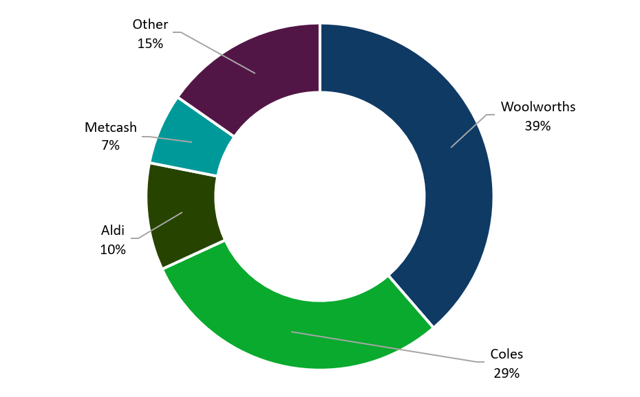
The supermarkets and grocery stores industry comprises 2,432 businesses, employing around 428,000 people. There is an annualised revenue contraction of 0.4% to $144.3 billion predicted over the five years to 2025–26. Revenue is expected to rise at an annualised rate of 1.5% to $155.6 billion in 2030–31.
The three largest food and grocery retailers are Woolworths, Coles and Aldi, and the largest food and grocery wholesaler is Metcash. Together they held 84.8% of market share in 2025, as shown in Figure 1.
In the 2023–24 financial year, according to ABS data which excludes fresh food, the food, beverage and grocery supply industry in Australia generated $172.7 billion in turnover and 294,212 jobs.

Code Supervisor’s activities

Engagement with the sector
In the first year of operation of the new Code, a key priority for the Code Supervisor was to undertake broad and meaningful engagement with stakeholders across the food and grocery sector to support awareness, confidence, and effective implementation of the Code. This included meetings with the responsible senior officers appointed under the Code from each of the large grocery businesses covered by the Code to discuss governance arrangements, operational implementation, dispute resolution processes, and emerging areas of focus.
The Code Supervisor also attended a range of industry conferences, forums, and board meetings throughout the reporting period to speak about the operation of the Code, its objectives, and the role of the Code Supervisor. These engagements provided an important opportunity to promote awareness of Code rights and obligations, encourage constructive engagement across the sector, and hear directly from industry participants regarding emerging issues and practical implementation challenges.
Consistent with the Code Supervisor’s oversight and monitoring functions, correspondence was issued to large grocery businesses if and where potential emerging systemic issues of concern had been identified. These engagements were directed toward improving understanding of Code obligations, promoting early resolution of concerns, and encouraging proactive compliance practices and comprehensive responses were received from the relevant large grocery businesses.
During the reporting period, the Code Supervisor undertook extensive engagement with suppliers, growers, and industry participants across multiple jurisdictions, including Tasmania, Queensland, Western Australia, and New South Wales. These visits provided valuable firsthand insight into the operational realities and commercial experiences of both fresh and packaged suppliers operating within the sector. Further supplier engagement activities are planned for Victoria and the Northern Territory in the coming reporting period to continue building national visibility and accessibility under the Code.
Several suppliers made confidential approaches to the Code Supervisor seeking clarification regarding dispute resolution pathways and the operation of various provisions of the Code. These approaches are pleasing to see reflecting greater confidence in the Code framework. These confidential engagements have assisted in identifying areas where further guidance, education, or procedural clarity may support improved understanding and confidence in the framework established by the Code as referred to in other parts of this report.
The Code Supervisor also engaged with the Australian Competition and Consumer Commission to discuss and document emerging systemic issues within the sector and to support broader regulatory awareness of trends and concerns arising through stakeholder engagement and dispute-related interactions.
In addition, the Code Supervisor met on a quarterly basis with Code Mediators appointed under the Code to monitor developments and trends in dispute resolution processes. Separate discussions also took place, as required, in relation to particular informal issues or matters requiring discussion. These engagements have contributed to greater consistency of understanding and ongoing communication regarding the practical operation of the Code.
Insights gathered through these various stakeholder engagements, supplier discussions, dispute-related interactions, conference participation, and regulatory meetings informed the development and design of the annual survey methodology and survey questions. The survey process was designed to support a deeper understanding of supplier experiences under the Code and to assist in identifying emerging themes, areas of concern, and opportunities for continued improvement in Code operation and compliance.

Formal complaints received
The Code Supervisor did not receive any requests from suppliers to review the complaints handling processes conducted by the Code Mediators from the commencement of the new code on 1 April 2025 to 30 June 2025.
From 1 July 2024 to 31 March 2025 when the previous code was in effect, the Independent Reviewer did not receive any supplier requests to review the complaints handling processes conducted by the Code Arbiters.

Code Supervisor’s observations on supplier awareness of the Code
Suppliers have advised the Code Supervisor that they are often unaware of the way in which the protections in the Code operate in the commercial realities they find themselves given their commercial dependence on the supermarkets to get their products on shelves for access by end consumers.
The Code Supervisor’s observation is that this leaves a potential gap between the existence of protections in the Code on one hand and suppliers understanding how the protections operate in this unique commercial environment.
The Code Supervisor sees it as clearly within the remit of the Code Supervisor function to advise suppliers that have approached the Code Supervisor to seek guidance about their rights and how to make use of the scope and operation of the protections under the Code.
Code Mediators also play an important albeit confined educative role under the Code by assisting suppliers to understand the dispute resolution pathways available to them, including informal resolution options, mediation processes, confidentiality protections, and procedural rights under the Code framework. While the Code Mediator role does not extend to providing legal advice to suppliers as to their rights under the Code, individual mediators may consider how best to deal with such requests to facilitate their function under the Code and foster greater engagement and willingness of suppliers to approach them.
However, given that the supplier sector comprises thousands of suppliers, a more structured and systematic education program across the supplier community would assist in improving overall awareness, consistency, understanding and early resolution of Code issues. For example, the Government’s Supporting Fresh Produce Suppliers – Food and Grocery Code Education Program will assist fresh produce suppliers covered by the Code in this regard.

Code Mediator reports
The four Code Mediators for each of the large grocery businesses covered by the Code each submitted reports as required reflecting their activities for the year. The reports reflect the shared experience that:
- the large grocery businesses each provide confidential and independent complaint channels, including access to the Code Mediator, who operates independently of supermarket commercial teams and is empowered to investigate concerns impartially
- suppliers continue to show a preference for informal dispute resolution with almost negligible formal complaints received.

Survey of suppliers

Process for conducting the survey
The 2024–25 survey of suppliers was available online from 16 October 2025 to 5 November 2025. The large grocery businesses sent the survey link to their suppliers as required by the Code.
419 suppliers responded to the survey. Many provided responses for each of the large grocery businesses they supply to, resulting in a total of 947 individual responses and a response rate of 14%. This is less than the previous year, where 500 suppliers responded to the survey, comprising 1,179 individual responses and a response rate of 17%. However, it is higher than 2022–23, where 279 suppliers responded to the survey, comprising 651 individual responses and a response rate of 11%.
Table 2: Survey distribution and responses
Large grocery business | Total number of suppliers | Number of suppliers that were sent the survey | Number of survey responses | Response rate
Aldi | 1,769 | 1,114 | 213 | 19%
Coles | 2,004 | 2,004 | 260 | 13%
Metcash | 1,812 | 935 | 175 | 19%
Woolworths | 2,695 | 2,535 | 299 | 12%
Total | 9,571 | 6,588 | 947 | 14%
In addition to the standard questions asked of suppliers, which are used to track changes in outcomes year-on-year, this year’s survey included a new set of additional, optional questions for suppliers of fresh produce and separate questions for suppliers of other product categories. These help build a better understanding of emerging issues facing specific groups in the sector and identify focus areas over the coming period.
Amendments to the survey design gave suppliers more opportunities to provide written responses explaining their answers to multiple choice questions. While acknowledging the sample size and self-selection, this change has supported a deeper understanding of the factors driving the quantitative survey outcomes and identify emerging themes that the survey had not directly sought responses on.
The data from these responses has been collated and transformed into a publicly available Power BI dashboard available at: https://grocerycodesupervisor.gov.au/reports-and-updates/dashboard. The dashboard presents the survey results and charts beyond those included in this report.

General observations
This year’s survey results show improvement in supplier relationships across a range of metrics but still facing persistent challenges.
Challenges in price negotiation transparency, promotional investment expectations, communication variability, and impacts on small or fresh produce suppliers remain prominent in the responses received.
A greater focus on qualitative responses this year revealed emerging themes experienced by suppliers beyond the survey questions. While many suppliers reported instances of constructive engagement with retailers, the most prominent, additional issues included difficulties in managing cost pressures from raw materials, concerns about private label processes and unpredictable logistics costs. Smaller suppliers also reported difficulties with invoicing systems and cash flow management.

Improved outcomes
There were improvements across numerous metrics. There was a 7% increase in suppliers reporting they are always treated fairly and respectfully on the previous year (49% to 56%) with particular improvements from suppliers to Coles. Only 1% of respondents reported the large grocery business frequently acts unreasonably or with duress, down from 3% in the previous year.
Suppliers reporting ‘no issues at all’ increased from 71% in the previous period to 74% for the 2024‍–‍25 reporting period. Most notably, suppliers to Woolworths reported an increase in experiencing ‘no issues’ from 64% to 73%, while Coles and Metcash saw smaller improvements in suppliers reporting no issues. Aldi’s results remained stable, maintaining the highest score on this metric. There was also a continued improvement in deductions without consent, down to 3% in the 2024‍–‍25 financial year.
Other positive developments include continued reductions in late payments, which was down to 6% from 8% in the previous reporting period.
A lower proportion of small businesses reported that large grocery businesses significantly reduced distribution across stores or distribution centres without reasonable notice and genuine commercial reason, which was down from 7% in the previous period to 3%.
Suppliers provided numerous examples of positive communication, constructive problem solving, and generally fair conduct from retailers. For example, suppliers wrote that:
- They are confident that interactions with the retailer were conducted fairly and that the business did not experience any issues.
- The retailer was an absolute pleasure to deal with – always super helpful, super responsive and reasonable in all areas in regard to doing business.
- After experiencing an issue the retailer’s decision was reversed and they worked proactively together to come to a positive resolution.

Emerging focus areas
While many indicators improved, suppliers also identified several areas where retailer performance remains inconsistent or concerning. Many suppliers proffered overarching frustrations with the lack of public clarity and understanding of the commercial pressures they face and the ways in which supermarkets may deflect or blur them. As one supplier stated:
The retailers have immense PR power and their focus on shrinkflation is an example of drawing attention away from the commercial pressure they place on suppliers. More needs to be done to help consumers appreciate all ranging and price points are in place to satisfy stringent retailer commercial expectations.

Range reviews
Suppliers generally report that the Code’s requirement that range review criteria be disclosed to suppliers is often defeated by supermarkets using a long shopping list of criteria expressed in high level and aspirational terms without disclosure of the weight that the supermarket will place on each of the criteria in undertaking the range review process. This allows supermarkets to cherry pick which of the criteria they will leverage and lean into in negotiations with different suppliers. Suppliers report that supermarkets will simply select the metric for each supplier that they are weakest in and leverage that to put pressure on the supplier.
Some suppliers found that the supermarkets interpretation of the criteria were largely unattainable in practice. Many suppliers noted that range review processes were short circuited in terms of the supplier’s ability to influence outcomes but could then be protracted and drawn out in terms of the supermarket’s decision-making. In particular, it would coincide with the outcome of other processes such as supplier requests for price increases or supermarket requests for promotional contribution to customer offer initiatives.
The following reflects themes noted by suppliers:
The hurdles set at a range review (rates of sales, retail margin, loyalty etc) are set so high that most products (even top sellers) will not meet these. These high hurdles are then used to apply pressure on suppliers often resulting in retailers’ margins. There should be some guidelines around how high hurdles can be set.

Ongoing changes to range review timings and scope has put unnecessary pressure – financial, supply chain and resources – on our business.

Category review notifications of 2 weeks is too short and their decision-making period is too long because the timeframe to launch is crunched which puts extreme pressure on packaging development and supply chains.

Retail margins and price negotiations
Suppliers consistently reported significant challenges in the price negotiation process, highlighting issues of fairness, transparency and ongoing pressure from major retailers. Nearly half of the responses (44%) described price negotiations as involved or challenging. Half of responses also said retailers ‘always or mostly’ seek incremental retail margin (that is, more discount) and investment during range reviews.
The following extracts from suppliers reflect consistent concerns raised:
Always a judgement call as there are so many levers a retailer can pull to manage the margin outcome they aspire to achieve.

The issue of ‘average margins’ and constant asks to move to being ‘above average’ is fundamentally unfair… designed to intimidate and extract additional margins.
Suppliers also reported experiencing inconsistent or opaque benchmarking practices. Several reported being told they were ‘below the category average’ and therefore ‘expected to give the large grocery business more margin without increasing prices charged to the consumer in stores.’ These comments reflect ongoing pressure felt by suppliers to meet challenging margin expectations.

Transparency in pricing metrics
This year’s survey sought to better understand fresh produce suppliers’ experience of using pricing metrics in negotiating contract terms. Fresh produce suppliers were asked if the large grocery business quotes a market price, whether they substantiate quality, quantity and location of products being used as a price comparison so the pricing is fair and transparent.
Of the 40 fresh produce suppliers who responded, they reported the following results:
- Always: 10%
- Mostly: 33%
- Occasionally: 10%
- Rarely: 35%
- Never: 13%
These findings indicate that nearly half of suppliers believe fair substantiation occurs rarely or not at all. Suppliers also noted concerns with the process. This is reflected in suppliers’ statements to the following effect:
The price increase process continues to be our most difficult area of engagement. The… team frequently manipulates data and delays decision-making, making it extremely challenging to progress genuine cost recovery.
Suppliers also raised concerns about inappropriate price benchmarking, for instance, using national averages where state-based averages may be the more relevant cost. Suppliers also shared experiences of targets or benchmarks never being communicated or where they have been provided, not disclosing the calculation method before being delisted for not meeting targets.

Promotions and investment
Consistent with prior years, 4% of suppliers reported being required to fund retailer promotions they consider unreasonable. Fresh produce suppliers in particular face consistent demands, with 63% saying they are ‘always’ or ‘mostly’ requested to support retailer promotions by discounting prices.
Figure 2: Fresh produce suppliers requested to support retailer promotions by discounting prices
Question: Are you requested to support retailer promotions by discounting prices?
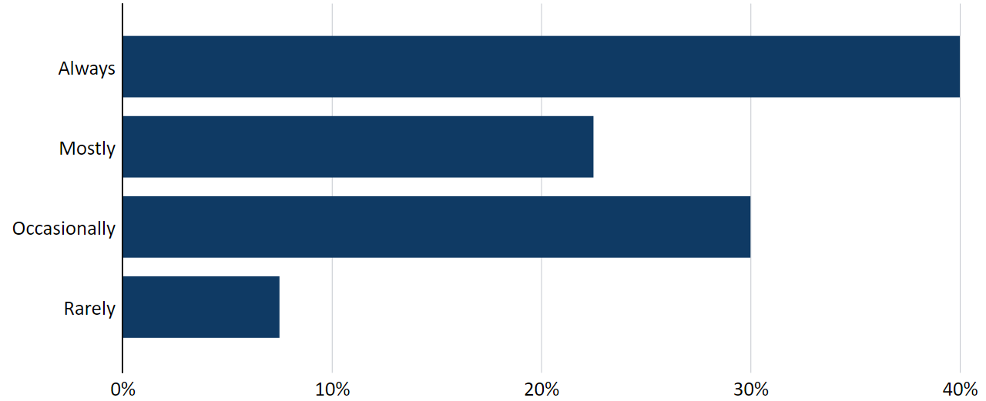
Yet as shown in Figure 3, only 12% believe that incremental investment ‘always’ leads to increased in-store activity or sales, while 47% said this is ‘rarely’ or ‘never’ the case.
Figure 3: Retailers’ requests for incremental investment linked to incremental instore activity and sales
Question: Are retailers’ requests for incremental investment linked to incremental instore activity and sales?
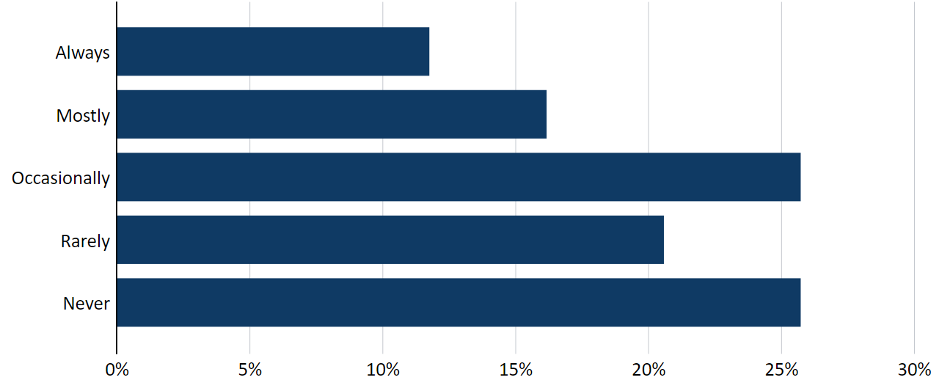
Flexibility is also limited—Figure 4 shows that only 29% reported they can ‘easily’ reduce retail media spend when shifting strategic direction.
Figure 4: Previous investment in retail media locked, that is, whether suppliers are able to easily reduce this investment if their media strategy changes
Question: Is previous investment in retail media locked i.e. are you able to easily reduce this investment if your media strategy changes?
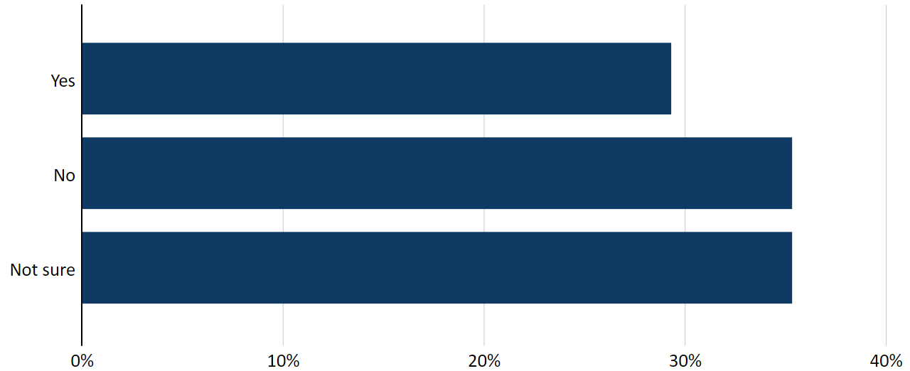
Qualitative responses highlight a growing emphasis on promotional ‘cycling,’ where retailers benchmark expectations not against current commercial conditions but against last year’s promotional intensity.
These results are reflected in suppliers’ statements in response to their ability to decline requests for promotional spend:
Retailers are constantly seeking great levels of support for promotional discounts to support sales.

Suppliers have significantly increased the frequency of promotions in last 18 months and the large grocery businesses expect this to be cycled year on year – in our experience it’s extremely difficult to reduce the frequency and depth of the previous.

Retailers have a cycling versus last year mentality, so any reduction is not accepted, and requests are always incrementally driven with asks for more activity or additional funding.

Promotional investment is increasing with less ROI in sales. 40% off and 50% off promotions secure the most activation.

Retribution
The general metric for suppliers’ fear of retribution when raising concerns with supermarket buying teams has decreased, dropping from 20% in the previous year to 13%. When asked if suppliers had experienced retribution, suppliers reported across the large grocery businesses:
Table 3: Experienced retribution in the last 12 months
Large grocery business | Yes | No | Not sure
Woolworths | 2% | 91% | 7%
Coles | 4% | 91% | 4%
Aldi | 1% | 94% | 4%
Metcash | 2% | 96% | 2%
While these results are largely positive there remains a notable proportion of suppliers who have reported being uncertain as to whether conduct was retribution. Uncertainty about what constitutes retribution may suggest ambiguity about what constitutes retribution or concerns of indirect consequences. Suppliers also reported in their written feedback that lack of visibility and understanding of decision-making processes can make it difficult to determine whether behaviour is retribution.
Noting that the concept of retribution is an untested concept, it is defined under the Code as a negative consequence for a supplier who has exercised its rights under the Code, but does not include an action that is not punishment or retaliation, and is for genuine commercial reasons. The assertion is therefore often made that not every negative commercial outcome for a supplier is retribution as defined in the Code. While that is certainly true, this assertion may be used to veil instances where a supplier has exercised a right under the Code and the large grocery business imposes a negative consequence which is characterised as a genuine commercial decision for that large grocery business, but is in fact retribution.
Looking at commercial rationales from the perspective of a large grocery business alone is not an ideal framework to identify retribution. There is extensive research looking at margin transfer from suppliers to retailers in Australia over the last two decades. It is therefore important to resist the temptation to explain away negative consequences on suppliers as objective commercial outcomes and consider the reasons why suppliers are protected under the Code and given the right to decline requests to range, price, promote, and list their products in particular ways. The commercial viability of a supplier to remain afloat and to invest in its own business to ensure sustainable operations is often a missing element in the analysis in these cases. This in turn feeds directly into the issues identified in the foreword section of this report including the integrity and sovereignty of Australia’s food supply chains.
As previously noted, the new targeted questions in this year’s survey focused on key points of interaction between suppliers and supermarkets and thus provide important colour and context to the concept of retribution as it plays out in commercial practice.
For example, it is useful to consider the following sample of extracts from suppliers in relation to the question of whether they felt comfortable saying no to a supermarket’s request for promotional spend:
Very real risk of delisting if not met.

It almost always is accompanied with a probable deletion. The outcome of a no would be deletion as the threshold is set as review, thresholds are unclear and applied to specific brands or areas.

You run a higher risk of deletion of existing line or non-acceptance of new line if you do not agree.

However, our perception is this increases the risk of an unsuccessful range review outcome.

When you do you often get punished.

There is always a margin grab by them, usually driven by range or brand reduction comments.

Comfortable to say no, however that rarely results in positive outcomes.

Feel like we really don’t have a choice.

Not comfortable if we have extra skus are to go in, they wont [sic] be ranged without additional support.

By saying no you are more than likely to reduce your businesses commercial outcomes as favour with the retailers will go to those suppliers that have supported incremental requests.

Every time you say no you place the future of the business relationship and ranging on the line.

There is no commercial return except for “paying to stay.”
The survey also asked respondents to consider the question of whether they are at liberty to change promotional spend and if it is effective or commercially worthwhile. The results suggest that, for some suppliers, sustained expectations of promotional participation may have contributed to a degree of dependence on promotional activity over time. Supplier responses indicate that reducing that activity may carry significant commercial risk, including for sales performance, ranging outcomes and broader business viability. The initiatives also continue to be used as a lever by the supermarkets, including in other processes like range reviews and pricing negotiations, in a manner which also raises issues concerning retribution.
Retailers are more interested in maintaining the status quo (total investment year on year or growing) and generally do not care about spend efficiency.

No, they will not accept less promotional activity, even with the increase in manufacturing costs.

Customers are now only buying on promo and not being loyal as a result.
It is possible to change funding on individual assortments, but the expectation is that total funding as a minimum is maintained and ideally increased.

Retailers are constantly seeking great levels of support for promotional discounts to support sales. We are expected to fund 50:50 with the retailers and activities will often not go ahead if this isn’t adhered to. In that case, the corresponding drop is sales results in pressures on ranging and growth discussions.

Promotional funding is much less efficient. no it cannot be changed without significant consequences.

No, both customers have stepped up the hunt for promo margin and almost always say that they will not run promos lower than base funding despite the fact that it has been that way for years.

Requests/demands for greater promotional funding and activity has increased. You can negotiate and change, however you are never certain if it will come back to bite you during category review process.

Suppliers have significantly increased the frequency of promotions in last 18 months and the large grocery businesses expect this to be cycled year on year – in our experience it’s extremely difficult to reduce the frequency and depth of the previous year’s promotional plan – especially with WOW and Coles.

No, always retribution.

Want more funding and promotions for less execution. There is ALWAYS some kind of retribution either short or medium term.

Depends on the retailer, but deeper promotions and more margin which is unreasonable.

Funding expectations have increased as reliance on deeper promotions to drive incremental volume have also increased.
The connection between price increases, range reviews, promotional spend requests and de-listings have been amply identified throughout this report. This reflects that, while there have been improvements, concerns about retribution continue to arise in the day-to-day supplier experience rather than an issue localised to fear of consequences when raising concerns under the Code. The improvement in the general retribution score whilst positive should be approached with these considerations in mind.

Communications and notice periods
While some communication metrics performance show improvement on the previous year, only 51% of supplier responses described large grocery businesses as ‘always’ communicating clearly, promptly and taking constructive action. 70% of suppliers reported receiving reasonable notice for de-listings or deranging.
However, qualitative feedback indicates that communication quality still varies widely. Many suppliers report in their written responses going extended periods with no responses, often attributing the lack of response to being intentional or tactical.

Fresh produce suppliers
Fresh produce suppliers continue to report some of the most challenging experiences in their dealings with large grocery retailers. Of the 40 fresh produce suppliers who responded, 13% said they ‘always’ consistently receive more in payment than it costs to grow their produce, and the same proportion reported ‘always’ being able to negotiate prices fairly.
Figure 5: Consistently receive prices for products that are above the cost to grow the products
Question: Do you consistently receive prices for products that are above the cost to grow the products?
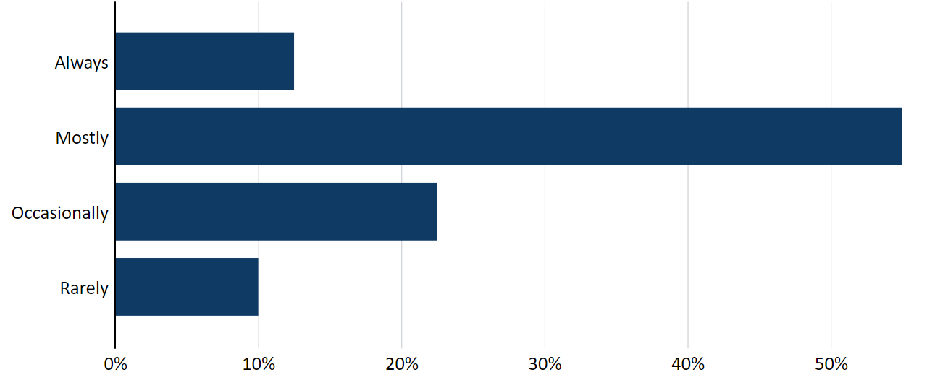

Figure 6: Able to negotiate prices fairly with the retailer
Question: In your opinion, are you able to negotiate prices fairly with the retailer?
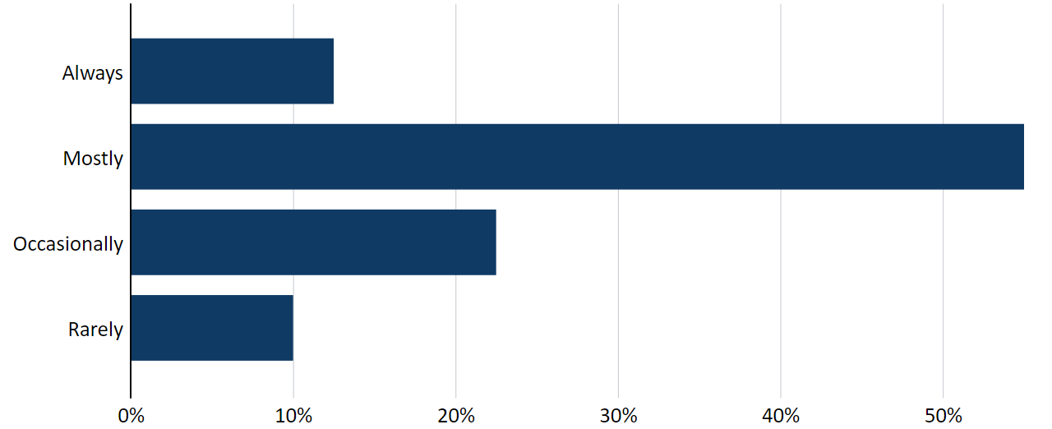
Of the 21 fresh produce suppliers who responded, 52% indicated they receive reasonable notice of delisting or deranging, the lowest of any supply category.
These pressures are intensified by the perishability of fresh produce, making unexpected changes harder to absorb, particularly for smaller growers, which were highlighted in their experiences provided by written responses. For example, many noted that cumulative charges and fees place further strain on already tight margins. One supplier stated that ‘combined rebates, agent fees, transport and other hire costs consume anything from 19% to 40% of the invoice.’ Another fresh produce supplier reported the challenges of absorbing the costs from ‘constantly being told to over supply stock daily to fill shelves so they ‘look full’ despite data showing the requested volumes are too high and our business bears the cost of the unsold produce.’
Many respondents expressed challenges competing with larger corporate fresh produce suppliers who can more readily absorb these costs. As a representative of this issue, one supplier noted ‘supermarkets internal structures favour corporate fruit production not family farms.’

Impacts on small businesses
Small businesses again reported some of the poorest overall experiences, with their limited cashflow, smaller operational capacity and narrower staffing buffers leaving them more exposed to adverse outcomes. They recorded the lowest performance on key fairness metrics, including ‘deals in good faith,’ where 2% reported ‘never’ and only 57% reported ‘always,’ among the weakest results across all business sizes, alongside similarly poor scores for ‘fair and reasonable dealings.’ Communication was also a challenge, with only 49% saying that large grocery businesses ‘always’ communicate clearly, promptly and take constructive action. The highest proportion of respondents reporting ‘never’ receiving such communication (2%) came from the smallest business category. Many noted they cannot absorb costs in the same way as larger competitors, with one supplier observing that ‘larger businesses have unfair competitive advantage in many cases.’

Contracting out exemptions
Large grocery businesses can contract out of certain obligations under the Code by making exceptions to the Code’s requirements in grocery supply agreements with their suppliers. In the second year asking suppliers about their experience of large grocery businesses requesting to contract out exceptions, there were notable shifts in results for all large grocery businesses. For example, last year, 3% to 5% of suppliers to each large grocery business reported the exceptions requested were ‘never’ reasonable. This year, less than 1% of suppliers to Coles and Woolworths reported these requests for exceptions being ‘never’ reasonable, and only 1% for Aldi and Metcash. However, reports of exceptions ‘always’ being reasonable also declined from an approximate average of 40% last year to 20% this year.
These shifts are likely due to improvements to this year’s question where suppliers were given the option of ‘not applicable,’ instead of ‘other.’ This year’s results establish an important baseline for measuring this issue in future years.
Figure 7: Experience in contracting out through exceptions
Question: Experience in contracting out through exceptions.
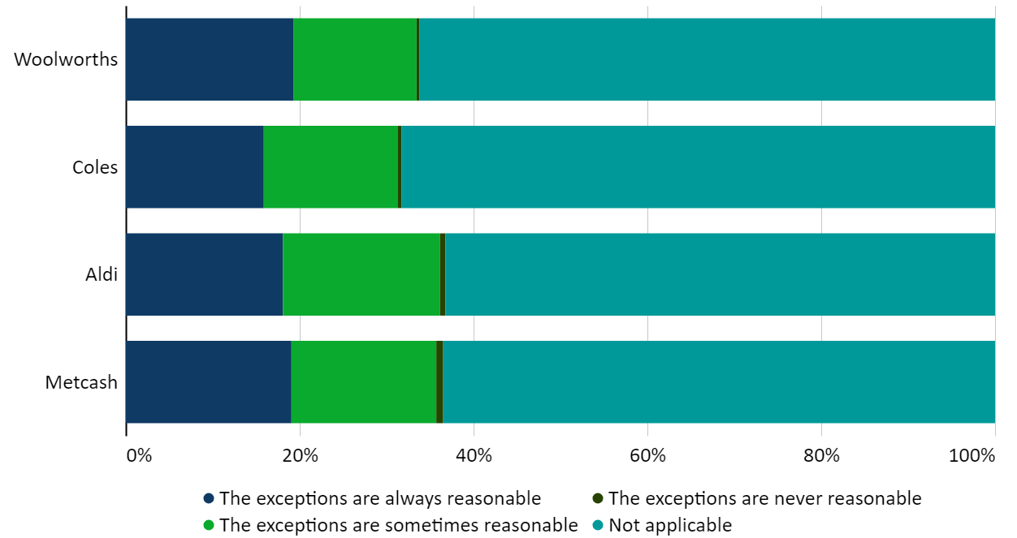

Conclusion
This year’s survey results reveal a sector progressing toward improvements in some areas of supplier relationships but still facing persistent structural challenges. Positive shifts—particularly around reduced fear of retribution, perceptions of fairness, and stable payment behaviours—indicate that compliance improvements and cultural emphasis on respectful dealings are taking hold.
However, complex commercial dynamics continue to impede consistent progress. Challenges in price negotiation transparency, promotional investment expectations, communication variability, and impacts on small or fresh produce suppliers remain prominent. These findings reinforce the value of this survey in monitoring industry behaviours and underline the ongoing need for regulatory guidance, capability development, and continued transparency from the large grocery businesses.

Survey methodology

Identification of key findings
Key findings from the survey are highlighted based on where results had the greatest shifts when compared to the previous year and core issues covered each year. The report also highlights results from new survey questions, especially where they offer new insights into emerging practices or concerns. Consistent with last year, this report highlights the survey results asking suppliers about their fear of retribution and experience contracting out exemptions, given the addition of these questions in the annual survey is required under the new code.
Qualitative comments, which have been edited for anonymity, are highlighted where the themes appear frequently or shed light on the ‘why’ behind quantitative results, helping to contextualise trends and deepen understanding. These elements ensure the report presents findings that are both representative of the data and informative for better understanding the food and grocery sector.

Overall score ranking methodology
The ranking methodology focuses on questions that directly measure behaviours and processes within the control of each large grocery business, such as fairness of dealings, timeliness and clarity of communication, responsiveness to issues, negotiation processes, and perceived impediments to raising concerns. These questions are included because they provide comparable, quantitative indicators of how each large grocery business interacts with suppliers—allowing meaningful year‑on‑year benchmarking. The methodology uses questions where suppliers can reasonably attribute their experience to the actions or systems of the large grocery business.
Questions that do not allow fair or consistent comparison are excluded. For example, questions where responses are heavily influenced by supplier behaviour rather than large grocery business conduct (for example, whether a supplier chose to request negotiations or lodge a complaint). In other cases, questions are excluded due to low response volumes, confidentiality concerns, or because differing supplier circumstances make results not reasonably comparable. Similarly, questions regarding Code Mediator or Code Supervisor processes are mostly excluded where uptake is low or where ranking might inadvertently discourage legitimate use of dispute resolution pathways. The survey uses largely the same metrics year-on-year with minor adjustments where questions have changed.

Survey of large grocery businesses
The fifth annual survey of large grocery businesses sought feedback on their relationship with suppliers, dispute resolution processes, negotiation and training. The survey also asked how the organisations are managing compliance with the new code, negotiations, steps taken to address suppliers’ fear of retribution, and the new provisions in the code, including management oversight and engagement with fresh produce suppliers.

Training and compliance
The large grocery businesses affirmed their commitment to strong, fair and mutually beneficial supplier relationships, with some noting that the Code provides a helpful framework for suppliers to raise concerns and build greater consistency across the sector. All large grocery businesses reported that buying teams receive code training such as induction and annual training. Most large grocery businesses have incorporated assessments to ensure employees’ understanding of obligations under the Code.
The large grocery businesses monitor code compliance through internal reporting processes, compliance audits and oversight by senior managers. Woolworths advised it has established a Supplier Oversight Committee and appointed a Director of Supplier Excellence, while Coles has appointed Compliance Business Partners to work closely with buying teams.

Supplier relationships

Communicating of dispute resolution avenues
The large grocery businesses reported using a range of methods to advise suppliers of the formal and informal dispute resolution options. They advised that these are communicated through websites, supplier portals, written materials (for example, in delisting and range review letters), supplier forums, onboarding processes and communications from its Code Mediators.

Price increase notifications and negotiations
The large grocery businesses reported having dedicated resources and system alerts to ensure timely handling of supplier price rise requests. Coles, Woolworths and Metcash noted updates to their internal processes for managing price increase notifications. ALDI reported that none of its price negotiations exceeded 30 days, while others noted extended timeframes can arise from the time it takes both large grocery businesses and suppliers to consider any issues or reasons that have arisen during a negotiation or waiting on further input or response from the supplier.

Range reviews and delisting
Coles and Woolworths acknowledged that range review outcomes can sometimes take longer than initially communicated due to the complexity and breadth of the range review, the need for further data validation, changes in market conditions or evolving customer insights. Metcash noted its range review outcomes generally do not take longer than originally communicated to a supplier, with occasional extensions mainly a result of category resets. ALDI stated that it does not conduct range reviews for delisting products and instead makes decisions about product performance and listings at any point during the contract.
Where the scope of range reviews expands beyond what was originally communicated, some large grocery businesses attributed this to a focus on ensuring relevant, high-quality and competitively priced products, including simplifying ranges to remove duplications. Others cited changing customer needs, category performance insights and strategic business priorities as reasons for an expanded scope.

Retribution
The large grocery businesses emphasised zero tolerance for retribution, supported by formal internal policies and senior management oversight to ensure that suppliers can raise concerns safely. They reported that confidential complaint channels are available to suppliers as well as clear communication of protections to suppliers and training for buying teams. The large grocery businesses reported that they do not regard de-listings, range rationalisation, promotional changes or category resets as retribution when based on genuine commercial reasons and applied transparently, without punitive intent.

Marketing support
The large grocery businesses described steps to ensure that promotional support terms remain optional and compliant with the Code including staff training, clear communication to suppliers and consideration of mutual benefits, costs and risks before agreeing to promotions.

Fresh produce
All large grocery businesses reported regular farm visits and direct engagement with growers to understand farming operations and challenges. Some large grocery businesses noted their use of forecasting tools and data analytics to improve forecast accuracy. The large grocery businesses stated that significant discrepancies between forecasts and actual volumes are rare and generally linked to unexpected demand, increased supplier availability or shifts in crop timing.
Price negotiations may involve both verbal and written exchanges, with final agreements typically confirmed in writing through quotes or portal submissions.

Effectiveness of the Code
The large grocery businesses expressed broad support for the Code’s principles of fairness and transparency. While some suggested no changes to the Code due to its recent introduction, others favoured less rigid, prescriptive procedural rules or exemptions for small entities. Some large grocery businesses emphasised the administrative costs of compliance and consider there are various issues with the Code, including with the magnitude of penalties. All large grocery businesses reported that they do not perceive any systemic issues.

IBISWorld, Industry Report, Supermarkets and Grocery Stores in Australia, July 2025, p 4.
IBISWorld, Industry Report, Supermarkets and Grocery Stores in Australia, July 2025, p 3.
IBISWorld, Industry Report, Supermarkets and Grocery Stores in Australia, July 2025, p 5.
IBISWorld, Industry Report, Supermarkets and Grocery Stores in Australia, July 2025, p 5.
IBISWorld, Industry Report, Supermarkets and Grocery Stores in Australia, July 2025, p 4.
Australian Food and Grocery Council, Annual Report 2024–25, p15. The employment figure is total number of employees, head count basis and does not include seasonal employees.
This excludes 1,433 charge-through suppliers who have more of an administrative and payment facilitation service and includes 142 suppliers of Rainfresh Vic Pty Ltd and Nu Fruit Pty Ltd which are related entities.
Small businesses refer to businesses with less than $10 million annual turnover.

